Mapping AI Job Replacement Anxiety on Reddit
A Social Media and Network Analysis of Career Concerns, Sentiment, Topics, and Influential Discussion Communities
Course: Social media and Network Analytics
Assessment: Assignment 2
Team Members:
Himanshu Sahu — Student ID: s4129901
Ayush Patel — Student ID: s4130673
Repository:
https://github.com/Himanshush79/SMNA_Assignment2_AI_Job_Anxiety
Date: May 2026

Executive Summary
This project examines how Reddit users discuss AI-related job replacement, occupational anxiety and reskilling. Our analysis applies methods of social media and network analysis to posts and comments from communities related to careers, jobs, technology and programming. The results integrate natural language processing, sentiment analysis, topic modeling and network analysis to characterize both the nature of user discussions and patterns of user interaction.

Use of Reddit was appropriate because this medium provides both textual and relational information on user activity. Text enabled analyses of keywords, bigrams, sentiment and topics of discussion. Relations among replies were used to generate a directed weighted network of user interactions. Our goal was to identify major themes of discussion, patterns of sentiment, influential users and communities of discussion related to anxiety about AI-related job replacement.

The final data included 23,525 records from 343 posts and 14,759 unique users. Sentiment analysis confirmed that discussions were predominantly of mixed valence (49.91% positive, 30.37% negative and 19.72% neutral). Three major topics of discussion were identified: adaptation to future patterns of work and to AI-based automation, and anxiety about opportunities for entry-level employment. The network of user interactions contained 14,759 nodes and 21,584 directed connections and reflected high levels of peer discussion about concerns related to AI-based job replacement.

Finally, our results confirm that discussions of AI-based job replacement on Reddit reflect not only perceived threats, but also opportunities for adaptation, reskilling and planning for future careers. Integration of methods of natural language processing and network analysis provided a more complete representation of the content and patterns of organization for discussions of anxiety about AI-based job replacement.

1. Introduction
The rapid development of generative artificial intelligence has intensified public debate about the future of work. Tools such as ChatGPT and other applications generate both optimism and concern. Some users regard artificial intelligence as a tool for enhancing learning, programming and retraining, whereas others are concerned that AI will reduce opportunities for entry-level positions, increase competition or provide justification for layoffs.
Reddit provides an excellent setting for studying these issues, because users openly discuss concerns about careers, job searching, technology and artificial intelligence. These interactions generate both textual and network information. Content reflects users' perceptions of job replacement by AI, whereas patterns of interaction reflect the ways users respond to and influence each other.

2. Research Questions
Here we examine anxiety about job replacement by AI on Reddit with methods of both text and network analysis. Our goal is not only to quantify common words and characterize sentiment, but also to obtain a better understanding of how themes of discussion and patterns of user interaction are interrelated. This is important because discussions on social media represent more than just aggregations of opinions; they also represent networks of users who challenge, support and disseminate ideas.
Our major research question was: How do users on Reddit discuss anxiety about replacement by AI, concerns about careers and strategies for retraining, and which users or communities exert the greatest influence on these discussions? To answer this question, we addressed four additional sub-questions:
RQ1. What are the dominant themes of discussion about replacement by AI and anxiety about careers?
RQ2. What is the overall tone of these discussions, and to what extent does this vary among different communities?
RQ3. Which users are most central to, or influential on, the network of interactions on Reddit?
RQ4. How do results of text analysis and network analysis together explain the mechanisms by which anxiety about replacement by AI spreads among communities on Reddit?

3. Data Source and Collection
The primary data source for this project was Reddit. This provided appropriate data for both NLP/text analysis and network analysis, because text for analysis was available in the form of posts and comments, and interaction network topology could be derived from patterns of comment-reply to relationships.
Implementation was restricted by the unavailability of public application creation for the Reddit API. As an alternative, we obtained a limited amount of academic data from public posts and comments in five accessible subreddits. All data retrieval was limited to publicly available information and achieved with sleep intervals sufficient to avoid exceeding public service limits on data access. The resulting dataset included 23,525 records. Data from the r/ArtificialIntelligence endpoint were unavailable because this endpoint returned a 404-error code during data retrieval. Consequently, our final dataset was based on data available from all remaining accessible subreddits.
This resulted in data from 343 public posts and comments, representing contributions by 14,759 unique authors. Information from five subreddits represented the following proportions of total data: 6,919 records (29.4%) from r/technology, 6,457 records (27.4%) from r/cscareerquestions, 4,842 records (20.6%) from r/jobs, 2,859 records (12.1%) from r/careerguidance, and 2,448 records (10.4%) from r/learnprogramming.
The most frequent search terms accounted for 4,686 records (19.9%) with searches for "AI jobs," 3,044 records (13.0%) with searches for "software engineering jobs," 3,000 records (12.8%) with searches for "automation," 2,892 records (12.4%) with searches for "AI layoffs," and 2,664 records (11.3%) with searches for "job replacement."
3.1 Targeted Subreddits
Finally, data from all planned subreddits were obtained. This included information from r/cscareerquestions, r/jobs, r/careerguidance, r/ArtificialIntelligence, r/technology, and r/learnprogramming.
3.2 Search Keywords
The following search keywords were used:
- AI jobs
- job replacement
- automation
- career anxiety
- ChatGPT jobs
- AI layoffs
- reskilling
- learn AI
- software engineering jobs
- entry level AI
- AI replacing programmers
- AI replacing developers
3.3 Dataset Fields
The data include fields for post ID, comment ID, subreddit, timestamp, author, parent author, title, text, score, number of comments, keyword, URL and parent ID. Following analysis, additional fields were added to represent cleaned text, VADER compound score, sentiment category, dominant topic of LDA and topic label.
Usernames were treated as public identifiers for the platform and not as identifiers for individual persons. Information such as API keys, passwords, access tokens and private credentials was not included in the repository or submitted files.

4. Methodology
4.1 NLP Pipeline
The text analysis follows the NLP pipeline presented in the lecture materials. Raw Reddit text is processed, filtered, tokenized, normalized and converted into vector representations for modeling and evaluation.
Preprocessing includes:
This prepares noisy text from social media for subsequent analysis. The resulting preprocessing facilitates identification of meaningful words and phrases related to AI, jobs, automation, career uncertainty and retraining.
4.2 Unigram and Bigram Analysis
Unigram analysis identifies frequent individual words, and bigram analysis identifies frequent pairs of words. Both approaches are important, because individual words reflect overall themes of discussion, whereas pairs of words retain substantially more meaning.
4.3 Sentiment Analysis
Results of unigram and bigram analysis provide an interpretable summary of the most frequent patterns of language in the data prior to application of more complex methods such as topic modeling. Classification of Reddit messages and comments as positive, neutral or negative was achieved with the VADER system, which is well-suited for analysis of text from social media because it incorporates methods for handling informal language and expressions of polarity.
The compound score is interpreted as follows:
Finally, our results confirm that discussions of AI-induced replacement of jobs on the Reddit forum are largely negative in tone.
4.4 Topic Modelling
Latent Dirichlet allocation is used to identify hidden themes in the text from Reddit.
Each topic is represented as a distribution of words, and each document as a mixture of topics.
Here, each post or comment is treated as a document.
The number of topics reflects considerations of interpretability and relevance to our research questions.
Topic labels were assigned by examination of the most highly weighted words within each topic and by assessment of the clinical relevance of the resulting patterns of topic representation to concerns about job replacement by AI.
4.5 Network Construction
A directed weighted network of replies to posts on Reddit was then constructed.
High rates of reply between pairs of users represented greater degrees of interaction.
4.6 Network Measures
The following measures of network organization were obtained: Numbers of replies received by individual users, numbers of replies given to other users, strengths of repeated interactions between pairs of users, and patterns of structural importance.
These measures identified users who attracted attention, users who actively responded to other users, users of structural importance and subgroups of users representing communities of discussion.

5. Results from Reddit Dataset
The final analysed dataset contains 23,525 records and 17 fields after preprocessing and analysis. It includes original Reddit metadata, cleaned text, VADER-derived sentiment scores and labels, dominant LDA topic assignments and manually interpreted topic labels. The resulting dataset is sufficiently large to allow both computational analysis of text and characterization of reply to networks.
Posts and comments were obtained from career, job search, technology and programming subreddits. Each record included metadata describing subreddit, author, parent author, title, text, score, number of comments, keywords, URLs and parent IDs. After analysis, the final exported dataset also included cleaned text, sentiment scores and labels, dominant topic assignments and labels for short phrases.
5.1 Keyword and Bigram Results
Analysis of unigrams and bigrams identified frequent terms and phrases related to entry-level positions, software engineering, automation, lay-offs, retraining, learning and anxiety about career outcomes. Results of unigram analysis reflected dominant individual terms used to describe the content of discussion posts, whereas results of bigram analysis preserved patterns of short phrase usage such as "entry-level," "software engineering" and "job market." These results confirm the overall focus of the project on issues related to employment, software engineering, automation and uncertainty about career outcomes. In addition, they demonstrate the utility of results obtained with short phrase analysis because they represent patterns of meaning more informative than results obtained with single words.
Figure 1 shows the top 20 unigrams in the dataset.
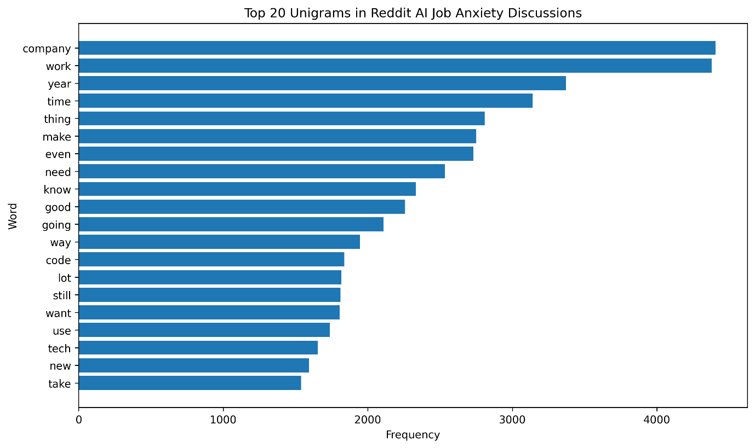Figure 1. Top 20 unigrams in Reddit AI job anxiety discussions.

Figure 2 shows the top 20 bigrams in the dataset.
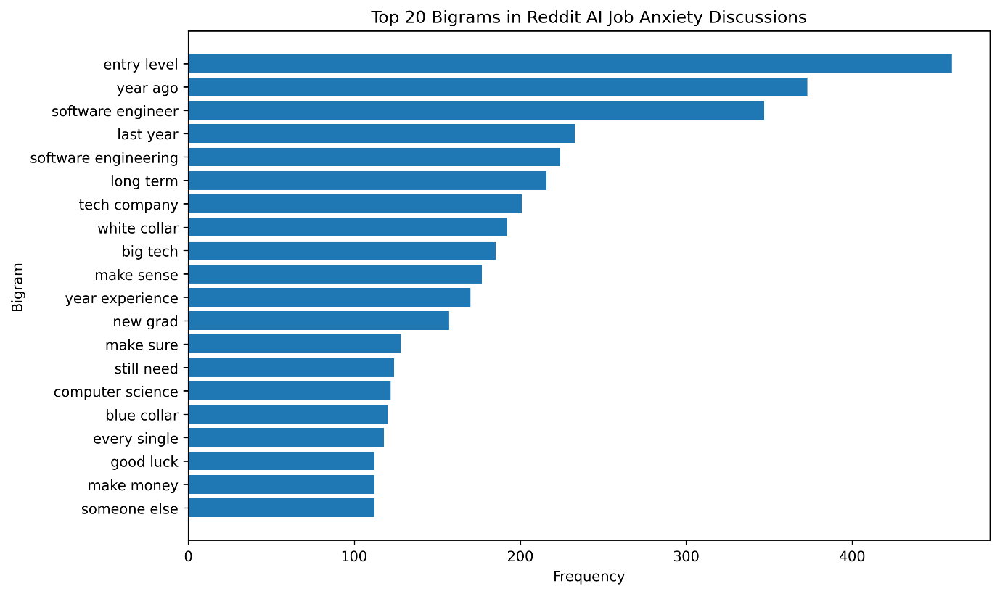Figure 2. Top 20 bigrams in Reddit AI job anxiety discussions.
5.2 Sentiment Results
The VADER sentiment analysis identified 11,741 positive, 7,144 negative and 4,640 neutral records. This corresponded to 49.91% positive, 30.37% negative and 19.72% neutral overall.
The results confirm that discussion of AI as a potential cause of job replacement is mixed and not uniformly negative. Positive comments generally described AI as a tool for increasing productivity, facilitating learning and retraining, and promoting future adaptation to work. Negative comments were more focused on concerns about job insecurity, layoffs, risks of automation and limited opportunities for entry-level positions. Neutral comments largely reflected a more factual or explanatory approach to describing the adoption of AI, changes in career or modes of adaptation to the workplace.
Sentiment | Number of Records | Percentage
Positive | 11,741 | 49.91%
Negative | 7,144 | 30.37%
Neutral | 4,640 | 19.72%
Finally, our results support the view that anxiety about the effects of AI on the Labor market is not simply an expression of negative opinion. Rather, the bulk of negative comments reflects only a relatively small proportion of all records. In fact, the largest category represented a positive view of the potential benefits of AI for the future of work.
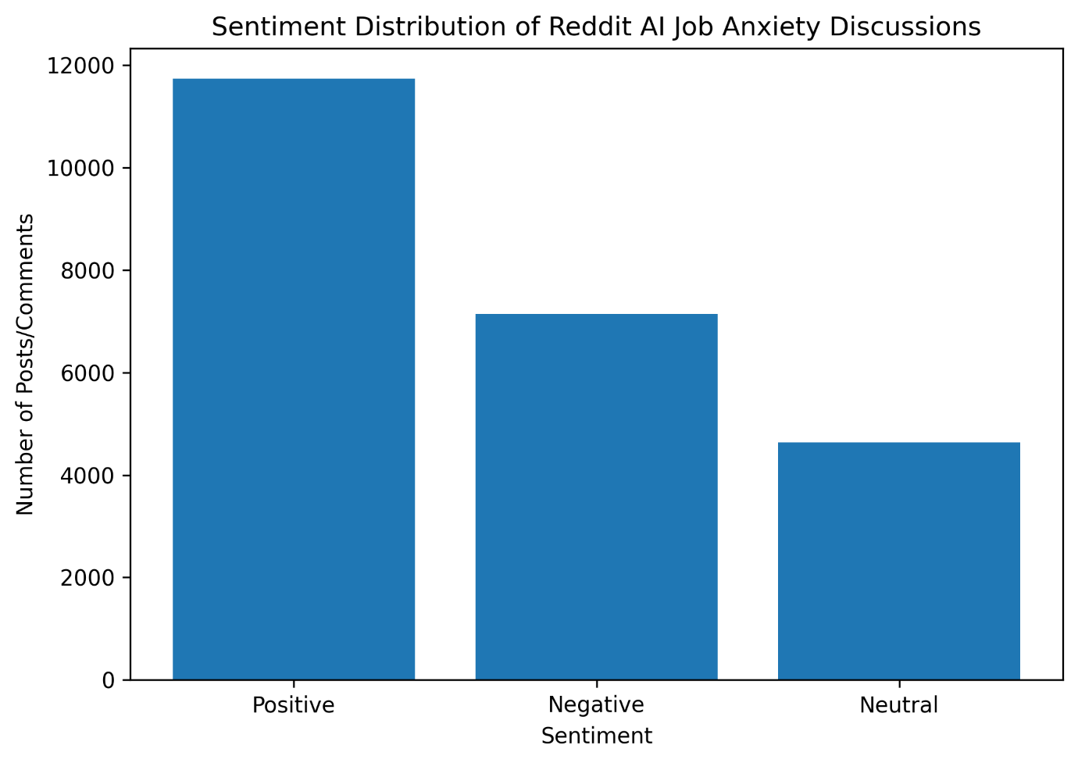Figure 3. Sentiment distribution of Reddit AI job anxiety discussions.
Figure 4 compares sentiment across the collected subreddits.
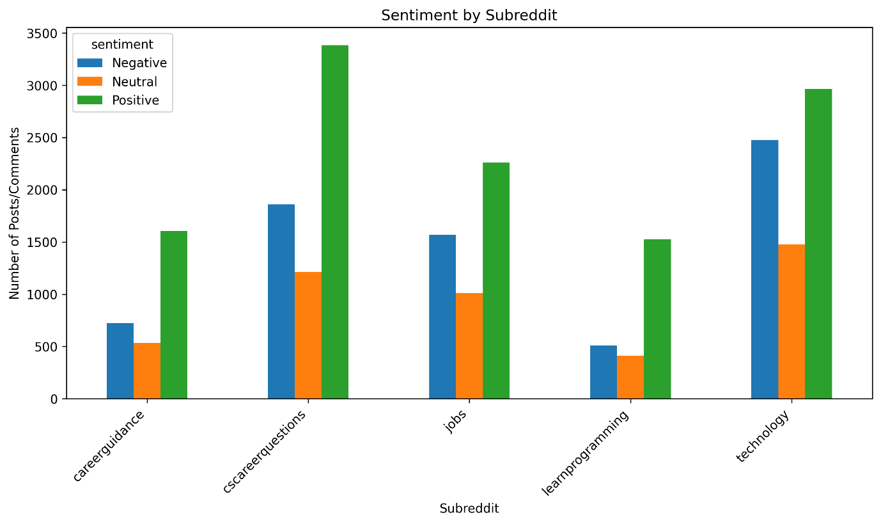Figure 4. Sentiment by subreddit.

5.3 Topic Modelling Results
The LDA topic model identified three major themes in the Reddit dataset. The dominant topic was "Reskilling and adaptation to future modes of work," with 9,809 records. This reflects discussion about acquisition of new skills, adaptation to AI tools and preparation for future changes in work.
Topic Label | Number of Records
Reskilling and future work adaptation | 9,809
AI adoption, automation, and productivity | 7,635
Career anxiety and entry-level concerns | 5,936
The second major topic was "Adoption of AI, automation and increases in productivity," with 7,635 records. This included discussion of AI implementation, automation, productivity and the overall impact of AI on work. The third topic represented "Anxiety about entry-level positions and concerns of students about future career prospects," with 5,936 records.
Topic Label | Number of Records | Interpretation
This included discussion of concerns about entry-level employment, internships, careers in software engineering and uncertainty experienced by students or individuals with limited experience. Our results confirm that anxiety about AI on Reddit is not solely a concern about risk of replacement. Rather, there was substantial emphasis on strategies for adaptation and for implementation of practical responses, particularly with respect to reskilling and acquisition of new knowledge.
This is consistent with the view that users were not merely discussing AI as a threat but also debating appropriate modes of response to AI-induced changes in work. Adoption of new skills, adaptation to AI technology and preparation for future modes of work. Use of AI, automation, increases in productivity and effects on modes of work.
Anxiety about entry-level positions, internships, careers in software engineering and concerns of students about future career prospects. The overall pattern of results supports the view that users were primarily concerned with strategies for adaptation to AI technology, rather than with anxiety about future replacement by AI.
Figure 5 shows the dominant topic distribution across the analysed Reddit records.
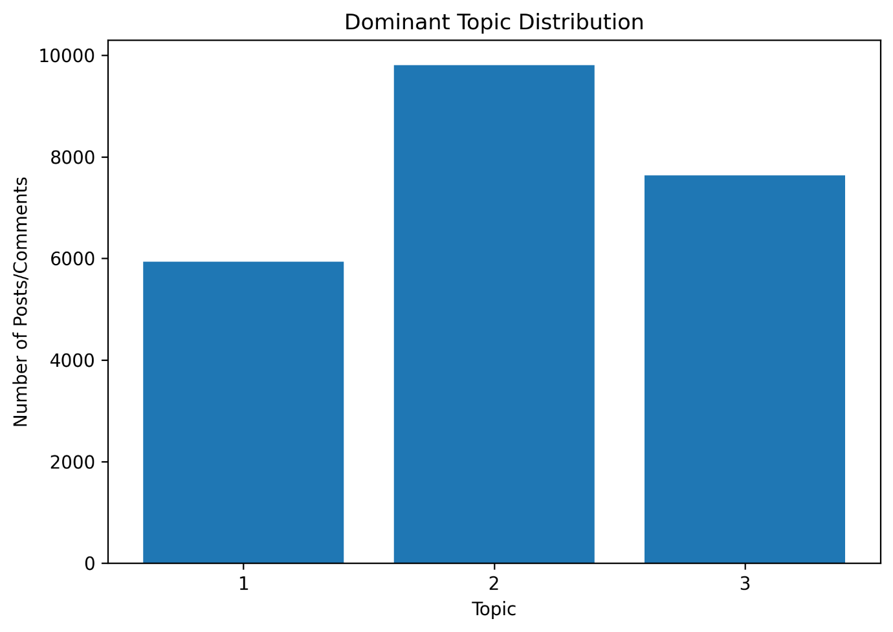Figure 5. Dominant topic distribution from LDA topic modelling.
5.4 Network Results
The full Reddit reply network comprises 14,759 nodes and 21,584 directed links. Nodes correspond to Reddit users, and directed links represent reply to interactions between users. As a result, the network reflects both the content of AI-related discussions of job anxiety and the structure of interactions among users.
Because the complete network is too large to visualize readily, we computed measures of centrality for the entire network and restricted network visualizations to the 200 users with the highest PageRank. This improved the clarity of results and avoided excessive overlap but retained representation of the most structurally influential users. High in-degree reflected large numbers of replies received by individual users and was interpreted as an indicator of attention-attracting behaviour.
High out-degree reflected active patterns of responding to other users. Measures of structural importance were greatest for users with high PageRank, and for those with high betweenness values that connected different components of the discussion. Overall, our results confirm that AI-related concerns about job anxiety are expressed not only by individual comments, but also by large, interactive structures in which users exchange information, discuss risks and develop a sense of community.
Figure 6 shows the Reddit reply network visualised using the top 200 users by PageRank.
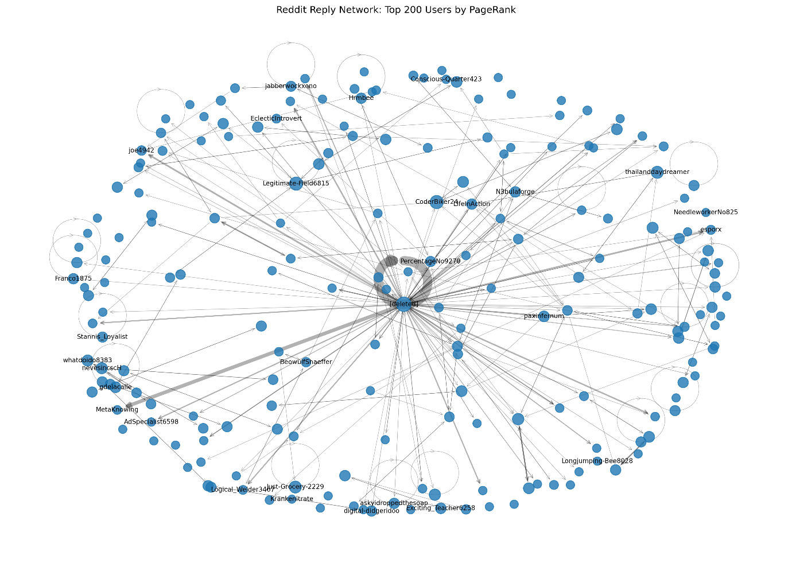Figure 6. Reddit reply network using the top 200 users by PageRank.

Figure 7 shows the same top 200 user network with Louvain community detection applied.
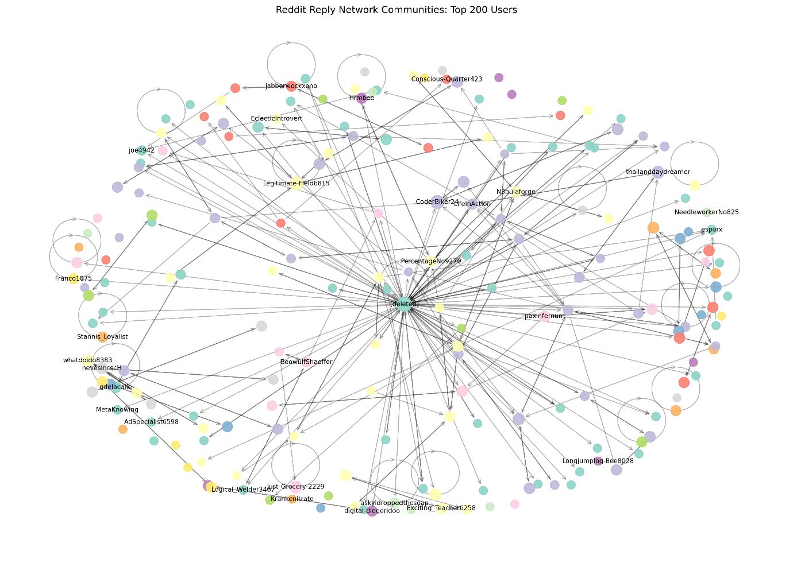Figure 7. Reddit reply network communities using Louvain community detection.

6. Discussion
Results confirm that discussions about AI job replacement on Reddit are complex and mixed. Although concerns about job insecurity and career anxiety are clear, they are not the only dominant themes. Sentiment analysis revealed that 49.91% of records were positive, 30.37% negative and 19.72% neutral. This indicates that most users describe their experience with AI in a practical or optimistic manner, particularly when discussing efforts to increase learning, productivity and capacity for adaptation to future work. However, the magnitude of negative responses remains large, reflecting continuing concerns about risk of displacement by automation and competition for entry-level positions. Overall, our findings support the view that anxiety about AI displaces work and spreads on Reddit both as an emotional experience and as a basis for discussions of practical coping strategies.
Most users expressed fear of replacement, displacement by automation and competition for entry-level positions, whereas others provided advice concerning strategies for retraining, learning to use AI tools and adapting approaches to career development. Results of topic modelling confirmed these impressions. The largest topic represented "strategies for retraining and adaptation to future work," and thus reflected the widespread tendency of users to respond to uncertainty about AI by discussing efforts to increase learning and capacity for adaptation to future work. A second major topic represented "adoption of AI, displacement by automation and increases in productivity," and illustrated broader discussions of the effects of AI on work and on methods of organizing business operations. A third major topic expressed concerns about competition for entry-level positions, and reflected fears concerning the future of training for internships, for careers in software engineering and for other entry-level positions.
Finally, our results of network analysis provide additional support for these conclusions. The total number of users and directed interactions within the complete system of responses was very large (i.e., 14,759 users and 21,584 directed interactions). This confirmed that our topic generated an enormous amount of interaction among users. Analyses of network centrality identified users who attracted responses, were active in responding to others or occupied positions of structural importance in the discussion. These results are of importance because influence in discussions of social media is not achieved only by frequent posting, but also by eliciting attention, integrating separate groups of users or participating in very large numbers of directed interactions.
The results also illustrate the value of integrating text analysis and network analysis. Text analysis identifies the topics of discussion, and network analysis identifies patterns of interaction with respect to those topics. Use of sentiment analysis alone would indicate that discussions were mixed. Use of topic modelling alone would reflect dominant themes of discussion. Use of network analysis alone would reflect modes of user interaction. Integration of these methods provides a more complete description of the nature of AI-related job anxiety, which was expressed in varying degrees of concern, advice for coping, adaptation to the situation and debate about its meaning.
7. Limitations
This work has several limitations.
First, users of Reddit are not representative of the general population. Our analyses likely overrepresent individuals with high knowledge of technology, students, job seekers or users already interested in AI or computer programming.
Second, our interpretation of sentiment may fail to recognize sarcasm, humor or complex emotional states. Our discussions included frequent use of informal language, jokes and expressions of disagreement that were difficult for lexicon-based tools such as VADER to interpret completely.
Third, loss of deleted or removed comments reduced the degree of completeness of our network.
Fourth, limitations of our API or search strategies influenced our dataset. We were unable to create an application for the Reddit API during the initial setup and therefore obtained our data by querying public JSON endpoints instead of by using authenticated access with the PRAW module. Access to the public JSON search endpoint for the r/ArtificialIntelligence subreddit resulted in a "404 not found" error and thus excluded this subreddit from our final dataset.
Finally, our analysis captured only visible interactions with the network. We did not include data on silent readers, on users who viewed but did not comment, or on effects that occurred outside the scope of our collected threads of discussion.

8. Teamwork and Management
The project is completed by a two-member team. While a team of three is preferred, project scope remains realistic with attention to a single social media platform and a single primary reply network.
Member | Main Role | Responsibilities
Himanshu Sahu | Data Collection and NLP Analysis | Reddit public JSON data acquisition, data preparation, text processing, analysis of keywords and word pairs, sentiment analysis with VADER, and topic modeling with LDA were used to generate the reply network, to perform analyses of network centralization and community structure, and to produce visualizations of network structure. All notebook, code, example data, figures, drafts of the report and files for project management were stored in a common repository.
Ayush Patel | Network Analysis and Communication | Records of weekly planning, meeting minutes, time allocations and individual reflections were maintained in the project management directory.
timesheets
8.1 Project Management Evidence
The repository includes:
- Python notebook and source code
- representative data files
- generated figures
- report draft and final report files
- team management plan
- weekly meeting records
- individual reflection notes
8.2 Team Contribution Summary
Helped select the topic of AI job anxiety and formulate research questions.
Refined the project scope and research questions.
Directed collection of public Reddit JSON data and preparation of the dataset.
Reviewed the structure of the dataset and contributed to documentation.
Conducted text cleaning, unigram and bigram analysis, sentiment analysis and topic modelling.
Interpreted results of NLP analyses.
Prepared author and parent author variables for network construction.
Directed development of the reply network, performed analyses of network centrality and identified network communities.
Wrote sections describing data collection, preprocessing and results of NLP analyses.
Authored sections describing results of network analyses and provided discussion and presentation of results.
Described methods of data collection, preprocessing, sentiment analysis, topic modelling, network construction and analysis. Also described results of these methods and interpretations of results.

9. Conclusion
We examined discussions of anxiety about replacement of jobs by AI on the online forum Reddit using text and network analysis. The resulting dataset included 23,525 records from 343 posts and 14,759 unique users. Sentiment analysis revealed mixed discussion with 49.91% positive, 30.37% negative and 19.72% neutral sentiment.

Three major topics were identified that represented concerns about adaptation to future work, adoption and implementation of AI and automation, and anxiety about entry-level career opportunities. User interactions with these topics were substantial, with a total of 21,584 directed links among 14,759 nodes. Measures of network centrality and community structure identified high-impact users and clusters of related discussion topics.

Overall, our results confirm that users on Reddit perceive replacement of jobs by AI as both a challenge and a threat to future employment. In combination with natural language processing and network analytic techniques, our work represents a more complete description of the content and organization of discussion about anxiety related to future job displacement by AI.
References
Blei, D.M., Ng, A.Y. and Jordan, M.I. 2003, ‘Latent Dirichlet Allocation’, Journal of Machine Learning Research, vol. 3, pp. 993–1022.
Hutto, C.J. and Gilbert, E. 2014, ‘VADER: A Parsimonious Rule-Based Model for Sentiment Analysis of Social Media Text’, Proceedings of the International AAAI Conference on Web and social media, vol. 8, no. 1, pp. 216–225.
Newman, M.E.J. 2010, Networks: An Introduction, Oxford University Press, Oxford.
Page, L., Brin, S., Motwani, R. and Winograd, T. 1999, The PageRank Citation Ranking: Bringing Order to the Web, Stanford InfoLab.
RMIT University 2026, Social Media and Network Analytics Lecture Slides, RMIT University, Melbourne.
Reddit 2026, Reddit Public JSON Endpoints and Public Subreddit Data, Reddit, viewed May 2026.

Appendix
Appendix A: Repository Structure
The project repository is organised as follows:
Folder/File | Purpose
README.md | Project overview, research questions, methods, and repository instructions
requirements.txt | Python libraries required to run the notebook and scripts
.gitignore | Prevents virtual environment, credentials, logs, and large datasets from being uploaded
data/ | Contains representative dataset files and centrality output files
notebooks/ | Contains the main Jupyter notebook for analysis
src/ | Contains Python scripts for Reddit data collection
figures/ | Contains all generated visualisations used in the report
management/ | Contains teamwork plan and project management evidence
presentation/ | Contains presentation materials if added
The full raw Reddit dataset and analysed full dataset were retained locally because their file sizes exceeded GitHub’s normal upload limits. The repository contains code, figures, notebook outputs, and representative data files sufficient to reproduce and understand the analysis workflow.
Appendix B: Dataset Fields
Field | Description
post_id | Reddit post identifier
comment_id | Reddit comment identifier
subreddit | Source subreddit
created_utc | Timestamp of post/comment
author | Reddit username or deleted marker
parent_author | User being replied to
title | Post title
text | Post or comment text
clean_text | Preprocessed version of the text
score | Reddit score/upvotes
num_comments | Number of comments on original post
keyword | Search keyword used for collection
compound | VADER compound sentiment score
sentiment | Sentiment category
dominant_topic | LDA dominant topic number
topic_label | Manual topic interpretation
parent_id | Parent post/comment ID
Appendix C: Team Management Evidence
Team management evidence includes:
- weekly project plan
- meeting logs
- timesheets
- individual reflection notes
- repository link and file list
- The detailed team management plan is stored in management/team_plan.md in the GitHub repository.

